KUBERNETES 01
- Setup Minikube in your local machine.
- Open power shell and run as administrator
- Install docker setup
- Winget minikube
- Minikube version
- 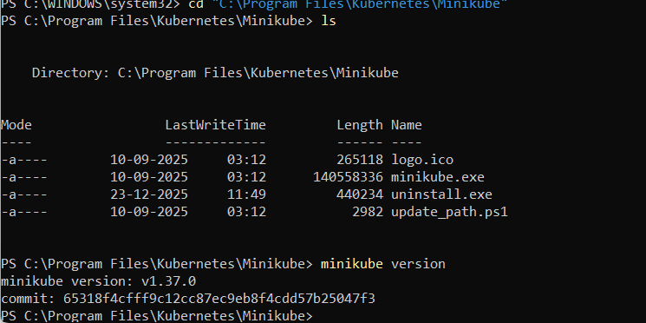
- Now, edit the environmental varibles and add
- Path
- 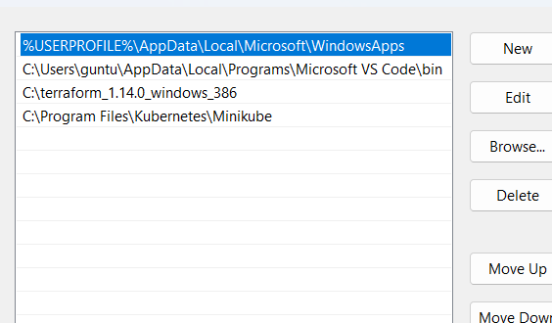
- Now, open vs code and
- Give command
- Minikube start
- 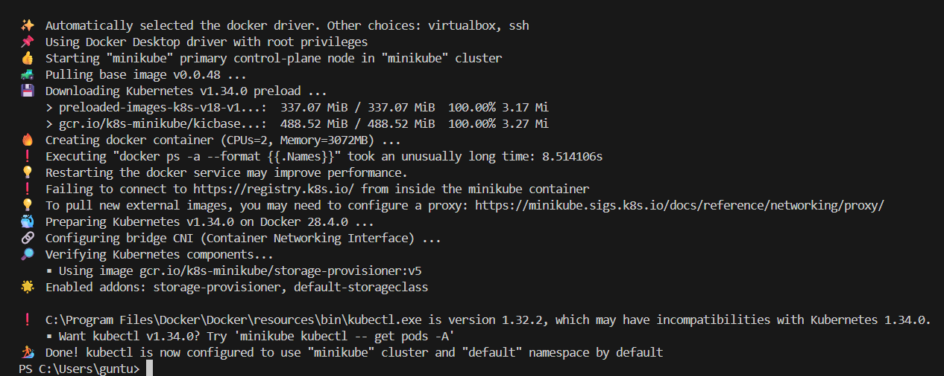

2 . . Setup k8s master and two worker nodes on ubuntu.

- Launch 3 instance with c7 large
- And 20gb
- Now, master
- Worker1
- Worker2
- Go to master and
- Gibe commands
- Hostname master
- Echo $hostname
- Vi /etc/hostname
- Remove ip and writr master
- Repeat the same for worker 1 and worker2
- 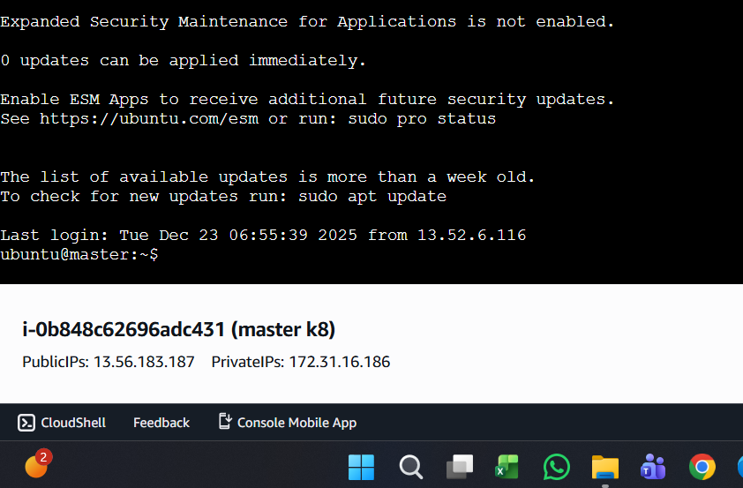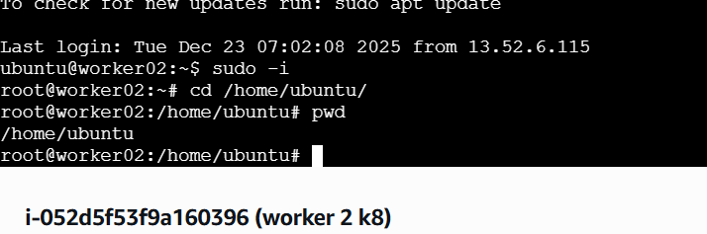
- Isntall docker in all 3 servers
- 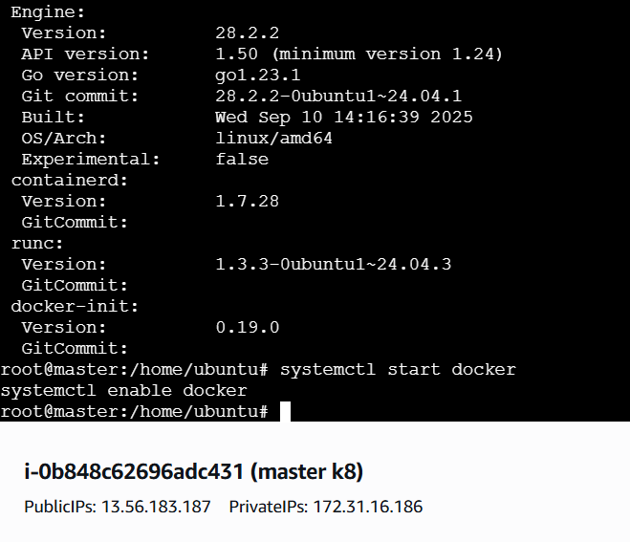
- Now install in all 3 servers
- kubeadm
- kubelet
- kubectl
- -------------------------------------------------
- 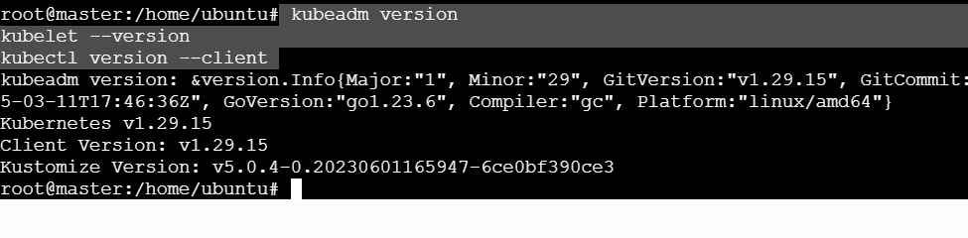
- Kubernetes Cluster Setup (1 Master + 2 Workers)
- OS: Ubuntu | Runtime: containerd | Network: Flannel

- 🔹 STEP 1: Update system (ALL NODES)
- sudo apt update

- 🔹 STEP 2: Disable swap (ALL NODES)
- sudo swapoff -a
- sudo sed -i '/ swap / s/^/#/' /etc/fstab

- 🔹 STEP 3: Load kernel modules (ALL NODES)
- sudo modprobe overlay
- sudo modprobe br_netfilter

- 🔹 STEP 4: Make kernel modules permanent (ALL NODES)
- cat <<EOF | sudo tee /etc/modules-load.d/k8s.conf
- overlay
- br_netfilter
- EOF

- 🔹 STEP 5: Set sysctl values for Kubernetes (ALL NODES)
- cat <<EOF | sudo tee /etc/sysctl.d/k8s.conf
- net.bridge.bridge-nf-call-iptables = 1
- net.bridge.bridge-nf-call-ip6tables = 1
- net.ipv4.ip_forward = 1
- EOF

- 🔹 STEP 6: Apply sysctl settings (ALL NODES)
- sudo sysctl --system

- 🔹 STEP 7: Install containerd (ALL NODES)
- sudo apt install -y containerd

- 🔹 STEP 8: Configure containerd (ALL NODES)
- sudo containerd config default | sudo tee /etc/containerd/config.toml

- 🔹 STEP 9: Restart and enable containerd (ALL NODES)
- sudo systemctl restart containerd
- sudo systemctl enable containerd

- 🔹 STEP 10: Install Kubernetes packages (ALL NODES)
- sudo apt install -y apt-transport-https ca-certificates curl
- curl -fsSL https://pkgs.k8s.io/core:/stable:/v1.29/deb/Release.key | sudo tee /etc/apt/keyrings/kubernetes.asc
- echo "deb [signed-by=/etc/apt/keyrings/kubernetes.asc] https://pkgs.k8s.io/core:/stable:/v1.29/deb/ /" | sudo tee /etc/apt/sources.list.d/kubernetes.list
- sudo apt update
- sudo apt install -y kubeadm kubelet kubectl
- sudo apt-mark hold kubeadm kubelet kubectl

- 🔹 STEP 11: Initialize master node (MASTER ONLY)
- sudo kubeadm init --pod-network-cidr=10.244.0.0/16

- 🔹 STEP 12: Configure kubectl access (MASTER ONLY)
- mkdir -p $HOME/.kube
- sudo cp /etc/kubernetes/admin.conf $HOME/.kube/config
- sudo chown $(id -u):$(id -g) $HOME/.kube/config

- 🔹 STEP 13: Install Flannel network plugin (MASTER ONLY)
- kubectl apply -f https://raw.githubusercontent.com/flannel-io/flannel/master/Documentation/kube-flannel.yml

- 🔹 STEP 14: Generate join command (MASTER ONLY)
- kubeadm token create --print-join-command

- 🔹 STEP 15: Join worker nodes (WORKER NODES)
- sudo kubeadm join <MASTER-IP>:6443 --token <TOKEN> --discovery-token-ca-cert-hash sha256:<HASH>

- 🔹 STEP 16: Fix worker NotReady issue (IF REQUIRED – WORKER)
- sudo modprobe br_netfilter
- sudo systemctl restart containerd
- sudo systemctl restart kubelet

- 🔹 STEP 17: Reset and rejoin worker (IF STILL NotReady)
- sudo kubeadm reset -f
- sudo rm -rf /etc/cni/net.d /var/lib/cni /var/lib/kubelet
- Then run STEP 15 again.

- 🔹 STEP 18: Verify cluster (MASTER ONLY)
- kubectl get nodes
- 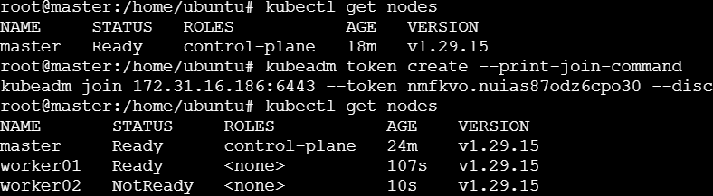
- 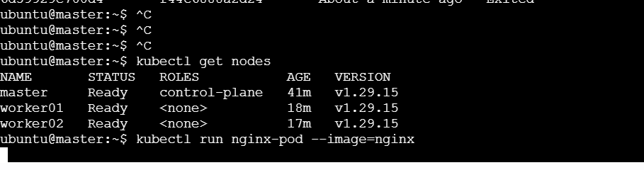

3 . run niginx pod
kubectl create deployment nginx-deploy --image=nginx
kubectl get deployments
kubectl get pods -o wide
- 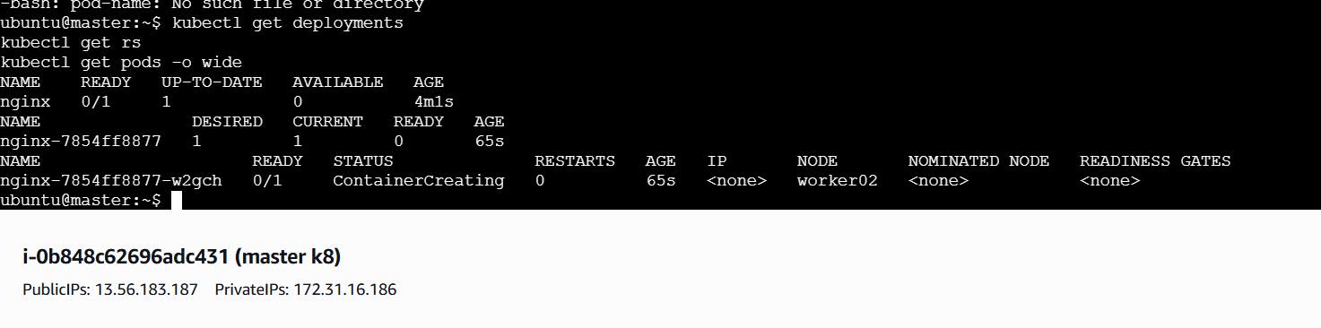
- Created successfully
4 . mug up master and slave components
Kubernetes Master (Control-Plane) Components
1️⃣ kube-apiserver
- Entry point of Kubernetes
- All commands go through this
- Talks to etcd
- Handles read & write requests
👉 “kubectl → kube-apiserver → cluster”

2️⃣ etcd
- Key-value database
- Stores cluster state
- Pods, nodes, configs, secrets
- If etcd is down → cluster is down
👉 “Kubernetes brain memory”

3️⃣ kube-scheduler
- Decides where pod should run
- Chooses best worker node
- Checks CPU, memory, labels, taints
👉 “Pod placement decider”

4️⃣ kube-controller-manager
- Runs controllers
- Node controller
- ReplicaSet controller
- Deployment controller
👉 “Maintains desired state”

5️⃣ cloud-controller-manager (optional)
- Talks to cloud provider (AWS, Azure)
- Load balancer
- Volumes
- Node lifecycle
👉 “Cloud integration”

🧠 Worker (Slave) Node Components
1️⃣ kubelet
- Agent running on worker
- Talks to API server
- Creates & manages pods
- Reports node status
👉 “Worker brain”

2️⃣ Container Runtime
- Runs containers
- Examples:
  - containerd
  - Docker
  - CRI-O
👉 “Actually runs containers”

3️⃣ kube-proxy
- Network component
- Handles service networking
- Load balances traffic to pods
- Uses iptables / ipvs
👉 “Service traffic manager”

4️⃣ Pods
- Smallest deployable unit
- One or more containers
- Runs application
👉 “Application lives here”

🎯 ONE-LINE MEMORY TRICK
Control Plane (MASTER):
API → ETCD → SCHEDULER → CONTROLLER
Worker Node:
KUBELET → CONTAINER RUNTIME → KUBE-PROXY → POD

🧪 Interview Rapid Fire (MUG-UP)
❓ Where does kubectl go?
👉 kube-apiserver
❓ Where is cluster data stored?
👉 etcd
❓ Who decides pod placement?
👉 kube-scheduler
❓ Who maintains desired state?
👉 controller-manager
❓ Who runs pods on worker?
👉 kubelet
❓ Who runs containers?
👉 container runtime
❓ Who manages service networking?
👉 kube-proxy

